Continuing Education/Continuing Medical Education (CE/CME)

Neonatal Intensive Care Nursing Specialty Certification Review Series (RNC-NIC)

WHEN: June 6, 2023 — 1:00 PM

Presentation purpose:

- Are you interested in obtaining your Neonatal Intensive Care Nursing specialty certification? This webinar series is designed for you. This series, offered over the summer, is targeted to nurses seeking to gain speciality certification in Neonatal Intensive Care Nursing. Presentations will cover topics identified as major content categories for the Neonatal Intensive Care Nursing exam through the National Certification Corporation. Unsure of your summer schedule? Each session can be attended virtually live or in a recorded format. We strongly encourage those interested to visit the NCC website at https://www.nccwebsite.org/ for additional information on NCC exam eligibility and candidate guidelines. Series dates: June 6, 2023; June 13, 2023; June 20, 2023; June 27, 2023; July 11,2023; July 18, 2023; July 25, 2023; Aug 1, 2023 Webinar time: 1300-1430 EST

Learning objectives:

Target audience:

This activity is designed for the interdisciplinary audience including the following:

Specialties: Neonatal

Professions: Nurse, Advanced Practice Nurse

Accreditation

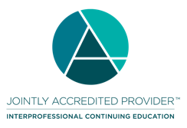
In support of improving patient care, Ascension is jointly accredited by the Accreditation Council for Continuing Medical Education (ACCME), the Accreditation Council for Pharmacy Education (ACPE), and the American Nurses Credentialing Center (ANCC), to provide continuing education for the healthcare team.

Credit designation:

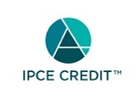

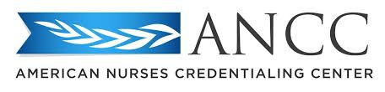

This activity is awarded 1.50 ANCC contact hour(s). (based on 60 minutes per contact hour)

Faculty/Course Director/Planners:

Ascension has selected all faculty participating in this activity. It is the policy of Ascension that all CE/CME planning committees, faculty, authors, editors, and staff disclose relationships with commercial interests upon nomination or invitation of participation. Disclosure documents are reviewed for potential conflicts of interest and if relevant, they are resolved prior to confirmation of participation. Only those participants who have no conflict of interest or who agreed to an identified resolution process prior to their participation were involved in this activity.

Conflict of Interest:

In accordance with the ACCME Standards for Commercial Support, it is the policy of Ascension to ensure balance, independence, objectivity and scientific rigor in all CE/CME activities.
Full disclosure of conflicts and conflict resolution will be made in writing via handout materials or syllabus.

Name of individual | Individual's role in activity | Name of Ineligible Company(s) / Nature of Relationship(s)
Kristi Browning, APRN | Faculty | Nothing to disclose - 02/23/2023
Jamalyn Casey, PharmD, BCPPS | Faculty | Nothing to disclose - 02/23/2023
Jessica Greene, APRN | Faculty | Nothing to disclose - 02/23/2023
Whitney Hammond, PA-C | Faculty | Nothing to disclose - 02/23/2023
Debra Moon, NP | Faculty | Nothing to disclose - 02/23/2023
Amy Mowery, APRN | Faculty | Nothing to disclose - 02/23/2023
Stacey L Yeo, APRN, NNP | Faculty | Nothing to disclose - 02/08/2023
Kathleen Oberhart, MSN, RNC-NIC | Faculty, Nurse Planner | Nothing to disclose - 11/08/2022

Commercial Support:

No commercial interest was received for this CE/CME activity.

