Continuing Education/Continuing Medical Education (CE/CME)

Defining Effective Treatment

WHEN: June 23, 2023 — 8:30 AM

Presentation purpose:

- Create a venue for additional discussion and civil debate of meaningful interventions and strategies, both regionally and nationally, to drive effective care for our patients.

Learning objectives:

- 1 Identify and examine the nature of the addiction epidemic in America
- 2 Review the modalities of care currently employed to respond to this epidemic
- 3 Review target populations
- 4 Identify documented effects of varied interventions on target populations and how this translates to applicability of the population

Target audience:

This activity is designed for the interdisciplinary audience including the following:

Specialties: Other

Professions: Physician, Nurse, Social Workers, Advanced Practice Nurse

Accreditation

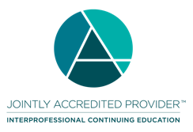
In support of improving patient care, Ascension is jointly accredited by the Accreditation Council for Continuing Medical Education (ACCME), the Accreditation Council for Pharmacy Education (ACPE), and the American Nurses Credentialing Center (ANCC), to provide continuing education for the healthcare team.

Credit designation:

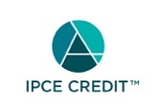

This activity was planned by and for the healthcare team, and learners will receive 1.50 IPCE credit(s) for learning and change.

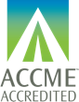

Ascension designates this Live Activity for a maximum of 1.50 AMA PRA Category 1 Credit(s)™. Physicians should claim only the credit commensurate with the extent of their participation in the activity.

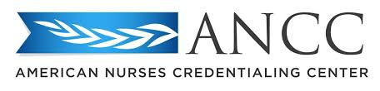

This activity is awarded 1.50 ANCC contact hour(s). (based on 60 minutes per contact hour)

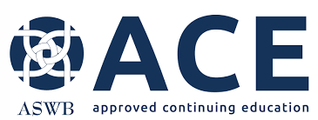

As a Jointly Accredited Organization, Ascension is approved to offer social work continuing education by the Association of Social Work Boards (ASWB) Approved Continuing Education (ACE) program. Organizations, not individual courses, are approved under this program. State and provincial regulatory boards have the final authority to determine whether an individual course may be accepted for continuing education credit. Ascension maintains responsibility for this course. Social workers completing this course receive 1.50 continuing education credits.

Faculty/Course Director/Planners:

Ascension has selected all faculty participating in this activity. It is the policy of Ascension that all CE/CME planning committees, faculty, authors, editors, and staff disclose relationships with commercial interests upon nomination or invitation of participation. Disclosure documents are reviewed for potential conflicts of interest and if relevant, they are resolved prior to confirmation of participation. Only those participants who have no conflict of interest or who agreed to an identified resolution process prior to their participation were involved in this activity.

Conflict of Interest:

In accordance with the ACCME Standards for Commercial Support, it is the policy of Ascension to ensure balance, independence, objectivity and scientific rigor in all CE/CME activities.
Full disclosure of conflicts and conflict resolution will be made in writing via handout materials or syllabus.

Name of individual | Individual's role in activity | Name of Ineligible Company(s) / Nature of Relationship(s)
Kelly Patton | Activity Administrator | Nothing to disclose - 03/30/2023
Barbara Shoup, RN, Mental Health Substance Use Disorders | Faculty, Nurse Planner | Nothing to disclose - 03/30/2023
Ismael D Yanga III, MD | Physician Planner | Nothing to disclose - 08/26/2022
Elise Hantula, MSW, Social Worker | Social Work Planner | Nothing to disclose - 11/08/2022

Commercial Support:

No commercial interest was received for this CE/CME activity.

