

Continuing Education/Continuing Medical Education (CE/CME)

Breast Cancer Screening Symposium

WHEN: October 7, 2023 — 9:30 AM

Presentation purpose:

- Operation Breast Density’s Breast Cancer Screening Symposium will be an educational Series taking a more individualized patient centered approach to Breast Cancer Screening. Its focus will be on breast density education and an understanding of the challenges that come with imaging women with dense breast. 6 lectures series 30 minute each.

Learning objectives:

- 1 Discuss what breast density is and how it is related to breast cancer development
- 2 Discuss how much breast density increase a women’s risk of breast cancer
- 3 Discuss how much breast density increase a women’s risk of breast cancer
- 4 Identify risk assessment tools for calculating risk of breast cancer development that
- include breast density
- 5 Distinguish when it is appropriate to order supplemental imaging for screening in high risk women

- 6 Illustrate how to accurately take a medical family history to know the indication for
- referral for genetic testing

- 7 Define the importance of an annual clinical breast exam for all women

- 8 Interpret how to appropriately code for supplemental imaging to increase insurance
- coverage

- 9 Identify additional options or programs available to patient for out of pocket
- discounted payments when insurance coverage is not provided for supplemental
- imaging

Target audience:

This activity is designed for the interdisciplinary audience including the following:

Specialties: Oncology

Accreditation

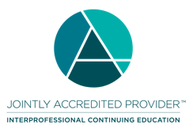
In support of improving patient care, Ascension is jointly accredited by the Accreditation Council for Continuing Medical Education (ACCME), the Accreditation Council for Pharmacy Education (ACPE), and the American Nurses Credentialing Center (ANCC), to provide continuing education for the healthcare team.



Credit designation:

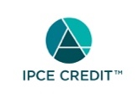

This activity was planned by and for the healthcare team, and learners will receive 3.00 IPCE credit(s) for learning and change.

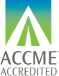

Ascension designates this Live Activity for a maximum of 3.00 AMA PRA Category 1 Credit(s)™. Physicians should claim only the credit commensurate with the extent of their participation in the activity.

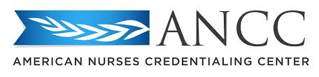

This activity is awarded 3.00 ANCC contact hour(s). (based on 60 minutes per contact hour)

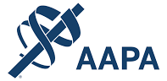

Ascension has been authorized by the American Academy of PAs (AAPA) to award AAPA Category 1 CME credit for activities planned in accordance with AAPA CME Criteria. This activity is designated for 3.00 AAPA Category 1 CME credits. PAs should only claim credit commensurate with the extent of their participation.



This knowledge-based activity qualifies for 3.00 contact hours of continuing pharmacy education credit. Pharmacy CE credits will be submitted electronically to the NABP upon successful completion of the activity.





Faculty/Course Director/Planners:

Ascension has selected all faculty participating in this activity. It is the policy of Ascension that all CE/CME planning committees, faculty, authors, editors, and staff disclose relationships with commercial interests upon nomination or invitation of participation. Disclosure documents are reviewed for potential conflicts of interest and if relevant, they are resolved prior to confirmation of participation. Only those participants who have no conflict of interest or who agreed to an identified resolution process prior to their participation were involved in this activity.

Conflict of Interest:

In accordance with the ACCME Standards for Commercial Support, it is the policy of Ascension to ensure balance, independence, objectivity and scientific rigor in all CE/CME activities.
Full disclosure of conflicts and conflict resolution will be made in writing via handout materials or syllabus.

Name of individual | Individual's role in activity | Name of Ineligible Company(s) / Nature of Relationship(s)
Jeffrey S Falk, MD | Faculty | Nothing to disclose - 12/23/2022
Shoshana Hallowell, MD, General Surgeon | Faculty, Physician Planner | Nothing to disclose - 09/12/2023
Versha Pleasant, MD, MPH | Faculty | Consulting Fee-InheRET - 12/16/2022
Evita Singh, MD | Faculty | Advisor-Hologic, Inc. - 09/12/2023

Commercial Support:

No commercial interest was received for this CE/CME activity.

