Continuing Education/Continuing Medical Education (CE/CME)

Words Matter Human Trafficking/Domestic Violence

WHEN: June 28, 2021 — 10:00 AM

Presentation purpose:

- Interactive educational presentation on Human Trafficking/domestic violence issues. How to identify victims, how to establish rapport, how to provide support and learn resources and how to address safety planning. Education on identifying ours and societies bias towards victims and begin to break down the biases.

Learning objectives:

- Will be able to identify a potential victim of trafficking or abuse/neglect.

- Will be able to know how to establish rapport with patient to gain needed information to help keep patient safe.
- Will be educated on how their actions help aid in the safety plan of the patient.

Target audience:

This activity is designed for the interdisciplinary audience including the following:

Specialties: Emergency Medicine

Accreditation

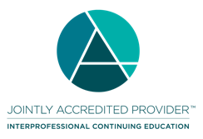
In support of improving patient care, Ascension is jointly accredited by the Accreditation Council for Continuing Medical Education (ACCME), the Accreditation Council for Pharmacy Education (ACPE), and the American Nurses Credentialing Center (ANCC), to provide continuing education for the healthcare team.

Credit designation:

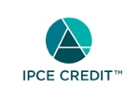

This activity was planned by and for the healthcare team, and learners will receive 3.00 IPCE credit(s) for learning and change.

Ascension designates this Live Activity for a maximum of 3.00 AMA PRA Category 1 Credit(s)™. Physicians should claim only the credit commensurate with the extent of their participation in the activity.

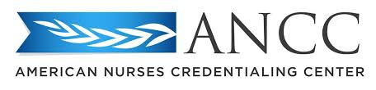

This activity is awarded 3.00 ANCC contact hour(s). (based on 60 minutes per contact hour)

Ascension has been authorized by the American Academy of PAs (AAPA) to award AAPA Category 1 CME credit for activities planned in accordance with AAPA CME Criteria. This activity is designated for 3.00 AAPA Category 1 CME credits. PAs should only claim credit commensurate with the extent of their participation.

As a Jointly Accredited Organization, Ascension is approved to offer social work continuing education by the Association of Social Work Boards (ASWB) Approved Continuing Education (ACE) program. Organizations, not individual courses, are approved under this program. State and provincial regulatory boards have the final authority to determine whether an individual course may be accepted for continuing education credit. Ascension maintains responsibility for this course. Social workers completing this course receive 3.00 continuing education credits.

Faculty/Course Director/Planners:

Ascension has selected all faculty participating in this activity. It is the policy of Ascension that all CE/CME planning committees, faculty, authors, editors, and staff disclose relationships with commercial interests upon nomination or invitation of participation. Disclosure documents are reviewed for potential conflicts of interest and if relevant, they are resolved prior to confirmation of participation. Only those participants who have no conflict of interest or who agreed to an identified resolution process prior to their participation were involved in this activity.

Conflict of Interest:

In accordance with the ACCME Standards for Commercial Support, it is the policy of Ascension to ensure balance, independence, objectivity and scientific rigor in all CE/CME activities.
Full disclosure of conflicts and conflict resolution will be made in writing via handout materials or syllabus.

Name of individual | Individual's role in activity | Name of commercial interest/Nature of relationship
Jennifer Jones, LMSW | Faculty | Nothing to disclose - 05/28/2021
Olivia Garver, Paramedic | Faculty, Other Planning Committee Member | Nothing to disclose - 05/28/2021
Crystal Pratt, RN | Faculty, Other Planning Committee Member | Nothing to disclose - 05/24/2021
Jennifer Jones, MSN | Other Planning Committee Member

Commercial Interest:

No commercial interest was received for this CE/CME activity.

