Continuing Education/Continuing Medical Education (CE/CME)

Create A Positive Workplace: Caregiver Conduct and PAUSE Session 3

WHEN: June 30, 2022 — 12:00 PM

Presentation purpose:

Learn about the Caregiver Conduct Toolkit which sits under the broader scope of our Preventing Workplace Violence Initiative. We will also learn PAUSE (Pause, Ask questions, Understand, Share observations, Explore resolutions). PAUSE is a simple and effective campaign developed to equip all associates to address incidents where they felt bullied or intimidated in interactions with other staff or patients. These sessions will include a small didactic piece to build awareness and then feature caregiver inspired stories to build knowledge and skill.
Use the link below to access the Zoom meetings and webinar:
https://ascension.zoom.us/j/96091728646

Learning objectives:

Target audience:

This activity is designed for the interdisciplinary audience including the following:

Professions: Nurse

Accreditation

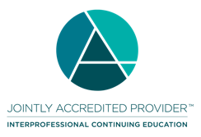
In support of improving patient care, Ascension is jointly accredited by the Accreditation Council for Continuing Medical Education (ACCME), the Accreditation Council for Pharmacy Education (ACPE), and the American Nurses Credentialing Center (ANCC), to provide continuing education for the healthcare team.

Credit designation:

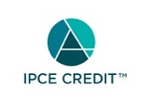

This activity is awarded 1.00 ANCC contact hour(s). (based on 60 minutes per contact hour)

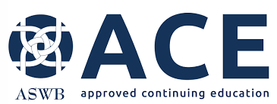

Faculty/Course Director/Planners:

Ascension has selected all faculty participating in this activity. It is the policy of Ascension that all CE/CME planning committees, faculty, authors, editors, and staff disclose relationships with commercial interests upon nomination or invitation of participation. Disclosure documents are reviewed for potential conflicts of interest and if relevant, they are resolved prior to confirmation of participation. Only those participants who have no conflict of interest or who agreed to an identified resolution process prior to their participation were involved in this activity.

Conflict of Interest:

In accordance with the ACCME Standards for Commercial Support, it is the policy of Ascension to ensure balance, independence, objectivity and scientific rigor in all CE/CME activities.
Full disclosure of conflicts and conflict resolution will be made in writing via handout materials or syllabus.

Name of individual | Individual's role in activity | Name of Ineligible Company(s) / Nature of Relationship(s)
Derek Bell, MSA, CWP | Faculty | Nothing to disclose - 04/11/2022
Maureen Chadwick, PhD, RN | Faculty | Nothing to disclose - 05/16/2022
Holly Meidl, MBA, ARM | Faculty | Nothing to disclose - 05/03/2022
Kristin Gilvin, BSN | Nurse Planner | Nothing to disclose - 01/10/2022
Elizabeth May, BSN | Nurse Planner | Nothing to disclose - 05/18/2022
Shannon Pearce, BSN | Nurse Planner | Nothing to disclose - 05/03/2022

Commercial Support:

No commercial interest was received for this CE/CME activity.

