Continuing Education/Continuing Medical Education (CE/CME)

Critical Care In Burn Patients

WHEN: October 27, 2022 — 1:00 PM

Presentation purpose:

- Dr. Meyer will be providing education on how to care for the critically ill burned patient. Content will cover acute burn physiology, fluid resuscitation of a large burn, modulation of hypermetabolic, sepsis, nutrition, inhalation injury and prognosis.

Learning objectives:

- 1 have beginning understanding of Acute Burn Physiology.
- 2 understand the need for fluid resuscitation for large burns
- 3 create plan of care for burn patients, related to lines, tubes, and nutrition.
- 4 identify potential complication with burn patients, such as sepsis and modulation of hypermetabolism.
- 5 gain knowledge of prognoses and care of burn patients.

Target audience:

This activity is designed for the interdisciplinary audience including the following:

Specialties: Critical Care Medicine

Professions: Physician, Physician Assistant, Nurse, Advanced Practice Nurse

Accreditation

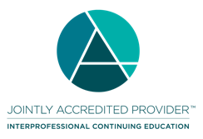
In support of improving patient care, Ascension is jointly accredited by the Accreditation Council for Continuing Medical Education (ACCME), the Accreditation Council for Pharmacy Education (ACPE), and the American Nurses Credentialing Center (ANCC), to provide continuing education for the healthcare team.

Credit designation:

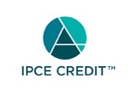

This activity was planned by and for the healthcare team, and learners will receive 1.00 IPCE credit(s) for learning and change.

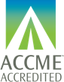

Ascension designates this Live Activity,PI CME activity,Internet point-of-care activity for a maximum of 1.00 AMA PRA Category 1 Credit(s)™. Physicians should claim only the credit commensurate with the extent of their participation in the activity.

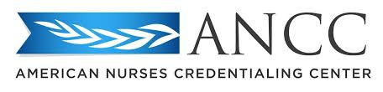

This activity is awarded 1.00 ANCC contact hour(s). (based on 60 minutes per contact hour)

Ascension has been authorized by the American Academy of PAs (AAPA) to award AAPA Category 1 CME credit for activities planned in accordance with AAPA CME Criteria. This activity is designated for 1.00 AAPA Category 1 CME credits. PAs should only claim credit commensurate with the extent of their participation.

Faculty/Course Director/Planners:

Ascension has selected all faculty participating in this activity. It is the policy of Ascension that all CE/CME planning committees, faculty, authors, editors, and staff disclose relationships with commercial interests upon nomination or invitation of participation. Disclosure documents are reviewed for potential conflicts of interest and if relevant, they are resolved prior to confirmation of participation. Only those participants who have no conflict of interest or who agreed to an identified resolution process prior to their participation were involved in this activity.

Conflict of Interest:

In accordance with the ACCME Standards for Commercial Support, it is the policy of Ascension to ensure balance, independence, objectivity and scientific rigor in all CE/CME activities.
Full disclosure of conflicts and conflict resolution will be made in writing via handout materials or syllabus.

Name of individual | Individual's role in activity | Name of Ineligible Company(s) / Nature of Relationship(s)
Nicholas Meyer, MD, General Surgeon; Burn Surgeon | Faculty, Physician Planner | Nothing to disclose - 08/18/2022
Xia Olig, BSN | Nurse Planner | Nothing to disclose - 08/01/2022
Caroline Joseph, PA-C | Other Planning Committee Member | Nothing to disclose - 08/18/2022
Melissa Kersten, NP-C | Other Planning Committee Member | Nothing to disclose - 08/18/2022

Commercial Support:

No commercial interest was received for this CE/CME activity.

