Continuing Education/Continuing Medical Education (CE/CME)

Stroke Symposium

WHEN: October 14, 2022 — 10:00 AM

Presentation purpose:

- Stroke Symposium: Increase your stroke knowledge with the Live/Virtual Event for Stroke on October 14th, 2022. Speakers will include Neurologist Dr. Stephen Trevick, Neurointerventionalist, Dr. Scott Geraghty, Neurology APN, Theresa Terna, Pharm-D, Christopher Hayek, CCC-SLP Laura Kinsey from Shirley Ryan Ability Lab, and CCC-SLP Patricia Scavuzzo.

Learning objectives:

Target audience:

This activity is designed for the interdisciplinary audience including the following:

Specialties: Neurology

Professions: Nurse, Advanced Practice Nurse

Accreditation

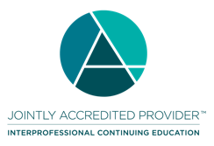
In support of improving patient care, Ascension is jointly accredited by the Accreditation Council for Continuing Medical Education (ACCME), the Accreditation Council for Pharmacy Education (ACPE), and the American Nurses Credentialing Center (ANCC), to provide continuing education for the healthcare team.

Credit designation:

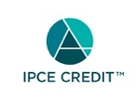

This activity was planned by and for the healthcare team, and learners will receive 5.00 IPCE credit(s) for learning and change.

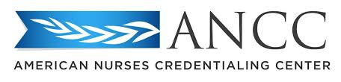

This activity is awarded 5.00 ANCC contact hour(s). (based on 60 minutes per contact hour)

Faculty/Course Director/Planners:

Ascension has selected all faculty participating in this activity. It is the policy of Ascension that all CE/CME planning committees, faculty, authors, editors, and staff disclose relationships with commercial interests upon nomination or invitation of participation. Disclosure documents are reviewed for potential conflicts of interest and if relevant, they are resolved prior to confirmation of participation. Only those participants who have no conflict of interest or who agreed to an identified resolution process prior to their participation were involved in this activity.

Conflict of Interest:

In accordance with the ACCME Standards for Commercial Support, it is the policy of Ascension to ensure balance, independence, objectivity and scientific rigor in all CE/CME activities.
Full disclosure of conflicts and conflict resolution will be made in writing via handout materials or syllabus.

Name of individual | Individual's role in activity | Name of Ineligible Company(s) / Nature of Relationship(s)
Sheri Garlick, PT | Activity Coordinator | Nothing to disclose - 08/16/2022
Jennifer Orde, MPH, RN, SCRN, MPH, CHES | Activity Coordinator | Nothing to disclose - 08/18/2022
Stephanie D Orr, DNP, SCRN | Activity Coordinator | Nothing to disclose - 08/17/2022
Scott Geraghty, MD | Faculty | Nothing to disclose - 08/16/2022
Christopher Hayek, PharmD, BCPS | Faculty | Nothing to disclose - 08/16/2022
Laura Kinsey, SLP, MS, CCC-SLP | Faculty | Nothing to disclose - 08/17/2022
Patricia A Scavuzzo, MS, Speech Pathology | Faculty | Nothing to disclose - 08/16/2022
Theresa Terna, APRN, MSN, APN, AGPCNP-BC | Faculty | Nothing to disclose - 08/24/2022
Stephen Trevick, MD | Faculty | Nothing to disclose - 02/16/2022

Commercial Support:

No commercial interest was received for this CE/CME activity.

